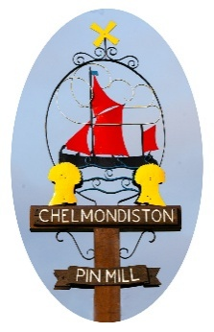
Chelmondiston Parish Council
The Village Hall, Main Road, Chelmondiston IP9 1DX
clerk@chelmondiston-pc.gov.uk

Grant Application Form

Organisation:

Amount of Grant Requested:

Reason for the Request & Financial Justification:
(if applicable, please attach any supporting photographs)

Requested By:
Position:

Signed:

Date:

